random number Demo

Video: <https://youtu.be/ITAQW0FN9Nk?list=PLhoApZD2CmJZsWvHw3fmoj2Tx4tc8vD98>

# Start our program

* 1. Start Visual Studio
  2. Create a new project. Call it “RandomDemo”. Add a cpp file as well and call it “RandomDemo.cpp”.
  3. Lay out our code:

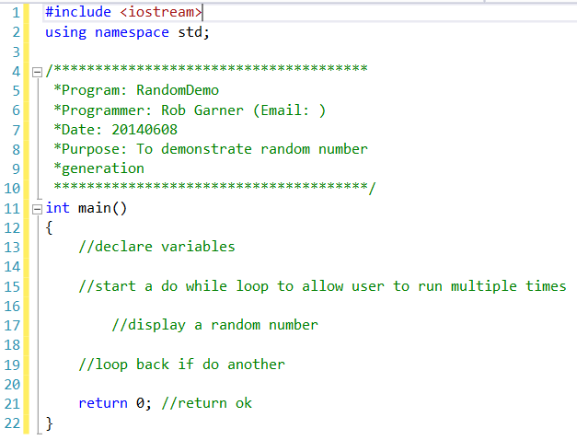

* 1. Add some code to make the loop work:

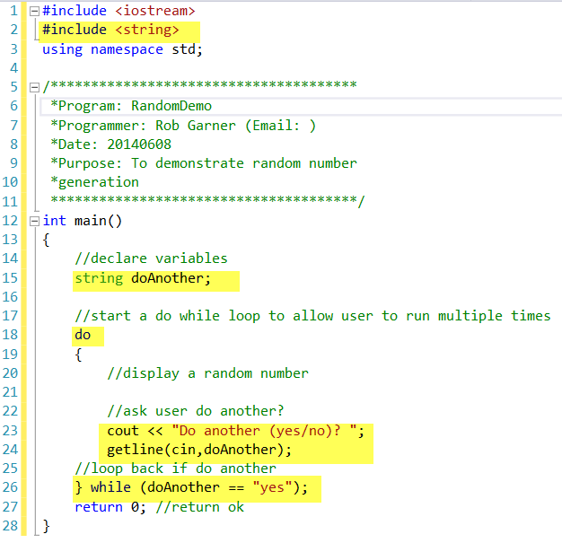

* 1. Try it with Ctrl-F5:

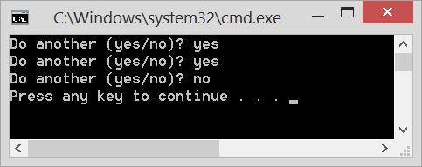

* 1. Our loop works! Let’s now add the display of a random number:

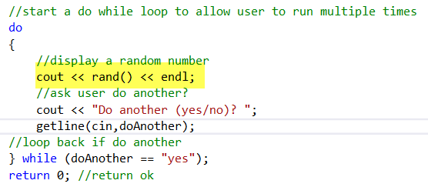

* 1. Try it with Ctrl-F5

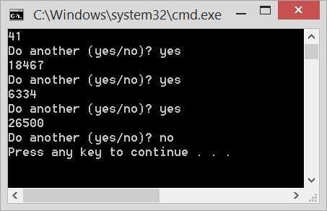

* 1. Try it again with Ctrl F5:



* 1. Notice that both times the results are the same sequence!
  2. Random numbers are actually not strictly random. If you don’t seed the random number generator you will get the same sequence each time. So add the following code:
  3. Add the following code:

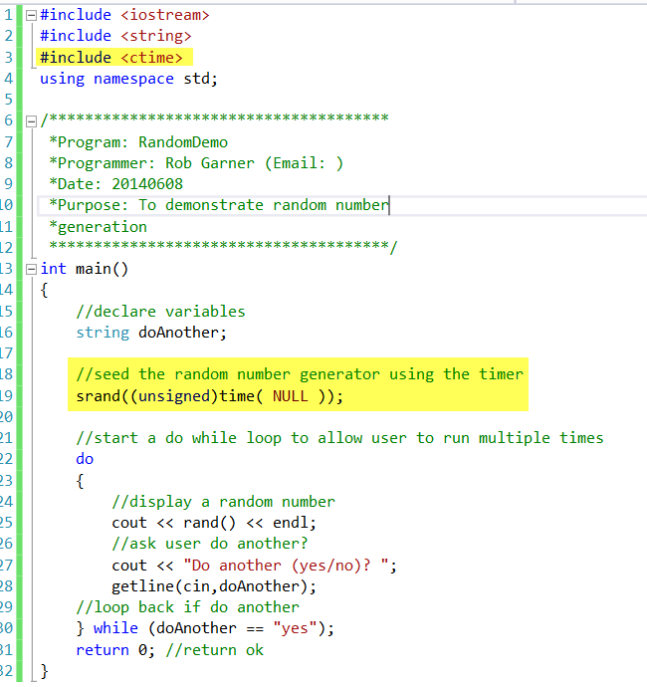

* 1. Try again two times with Ctrl-F5:

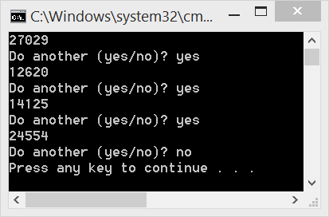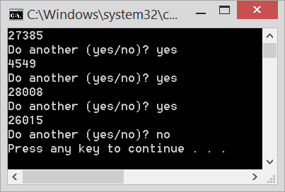

* 1. Notice that the numbers are now different each run.
  2. Suppose we wanted to simulate a six sided dice roll. We want results from 1 to 6. How would we code that? We can use the modulus operation. Lets try rand()%6:
  3. Add the following code:

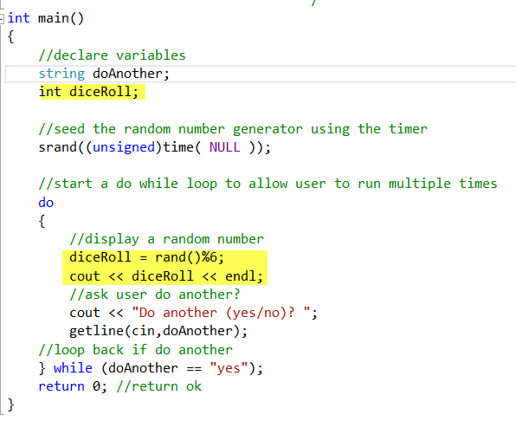

* 1. Try it with Ctrl-F5:

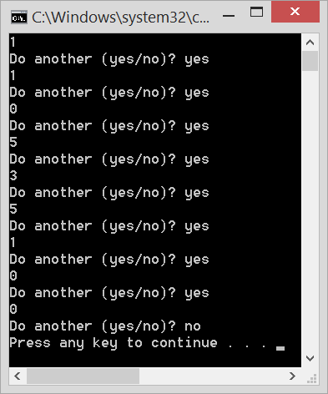

* 1. Notice we get 0s and we don’t get 6s. Why is that?
  2. Well, using the modulus operation rand()%6 means we can’t get a 6. However if we change that to 7 then we would get 0 through 6 which would also be wrong. To fix it we need to just add one:

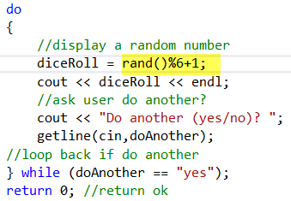

* 1. Now try it again with Ctrl-F5:

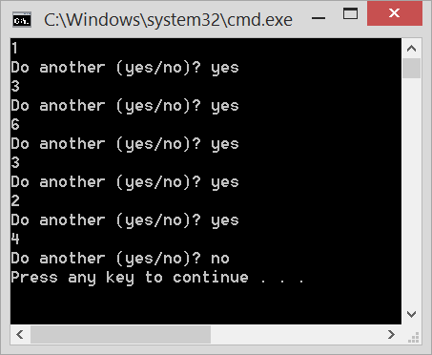

* 1. Now we see we are getting a proper distribution between 1 and 6.
  2. Try with other distributions example 3-15 for example.
  3. Try simulating the results of 3 dice rolls (hint do rand()%6+1 three times and add them together).